- Add more stuff to answers (1 word answers, add what specific trace or whatever)

tinybrowse -- Assignment 1: Intro to tinybrowse and tools
Name: [DAVID REN]

Follow the directions in assignment1.md, which lists the point value of each question.
Do not delete the square brackets -- put your answer between them. Short-answer questions should be concise, ideally only 1 or 2 sentences. Any question with multiple answers should be supplied as a comma-separated list

--- Part 1: Using grep ---

1.1
file:line of array_new's real definition: [src/tinyscript/array.cpp:22]

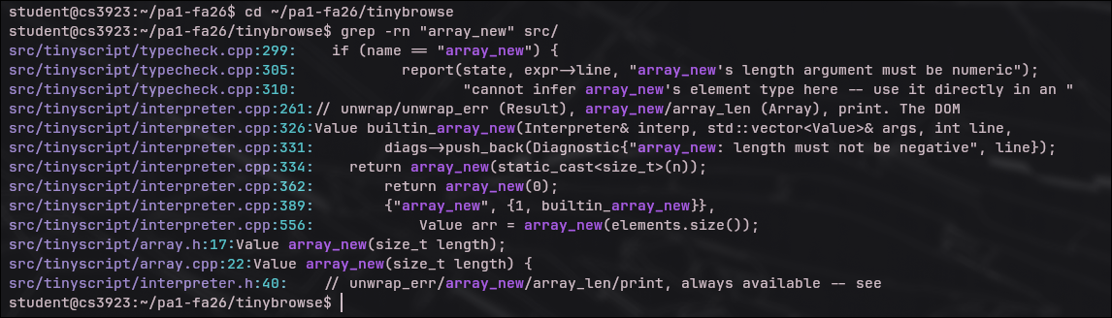

1.2
builtins found via core_builtins(): [ Ok, Err, is_ok, is_err, unwrap, unwrap_err, array_new, array_len, array_concat, array_pop, print]
builtins found via register_builtin(...) calls: [ getElementById, getAttribute, setAttribute, setText, setHtml, on, firstChild]

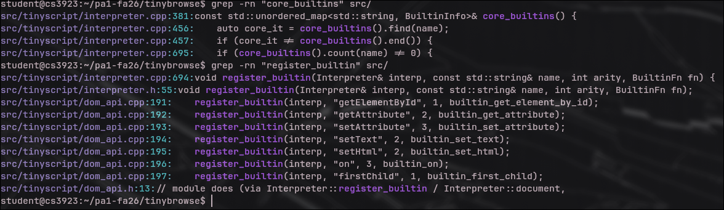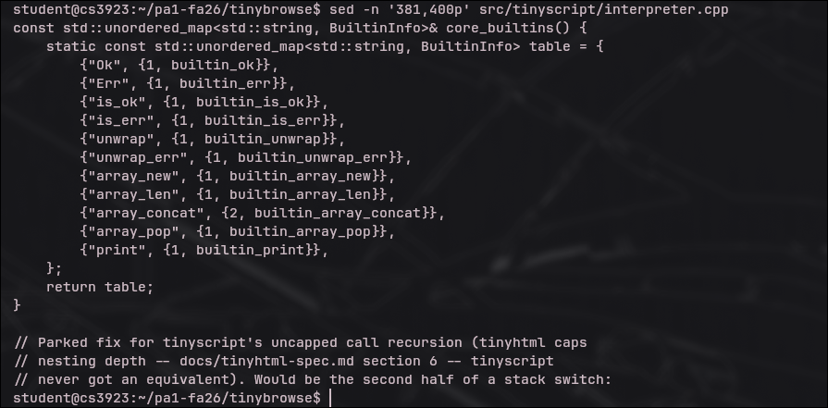

1.3 -- threat modeling

files that perform raw new/delete:

[src/tinyscript/value.cpp, src/tinyscript/parser.cpp, src/tinyscript/typecheck.cpp, src/tinyscript/interpreter.cpp, src/tinyscript/array.cpp, src/tinyscript/ast.cpp, src/tinyscript/dom_api.cpp, src/tinyscript/type.cpp, src/tinyhtml/parser.cpp, src/tinyhtml/dom.cpp]

did you expect all of these to manage memory directly? which (if any) surprised you:

[Not all of them. I expected parser, AST, type, value, and DOM-related code to manage memory directly because they create and destroy syntax-tree nodes, values, types, arrays, and DOM nodes. The more surprising files were interpreter.cpp and dom_api.cpp, since I initially expected them to mostly execute logic or expose APIs rather than perform raw allocation themselves.]\
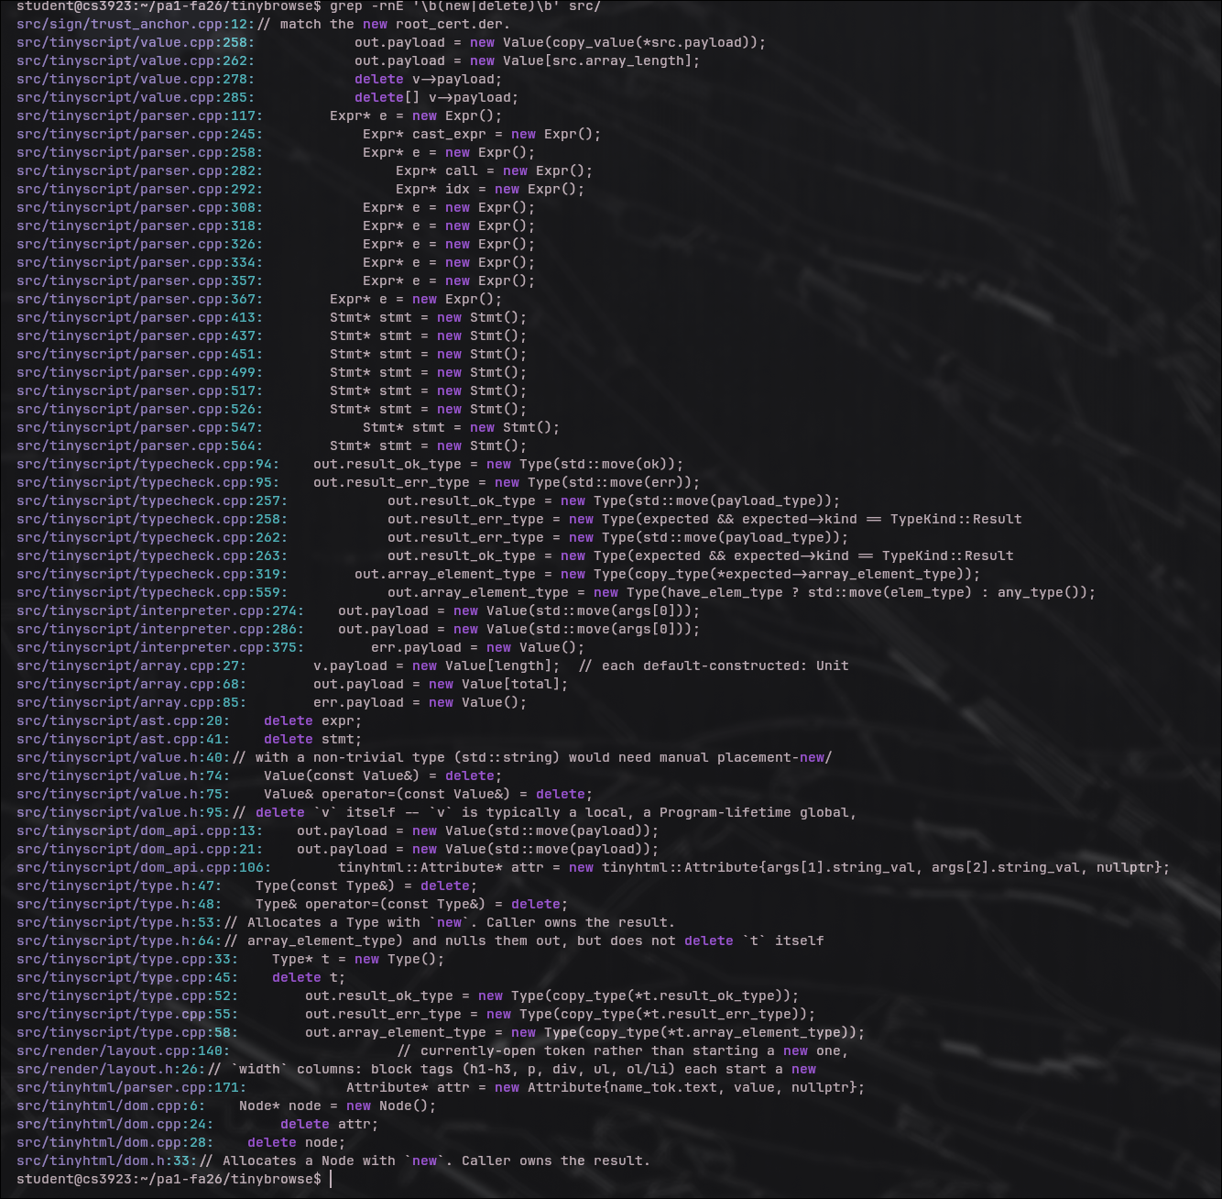

--- Part 2: Using GDB ---

2.1
path value at load_and_render breakpoint:

[examples/tinyscript-demo.thtml]

the only other stack frame (function name, file:line):

[main,src/browser/main.cpp:35]

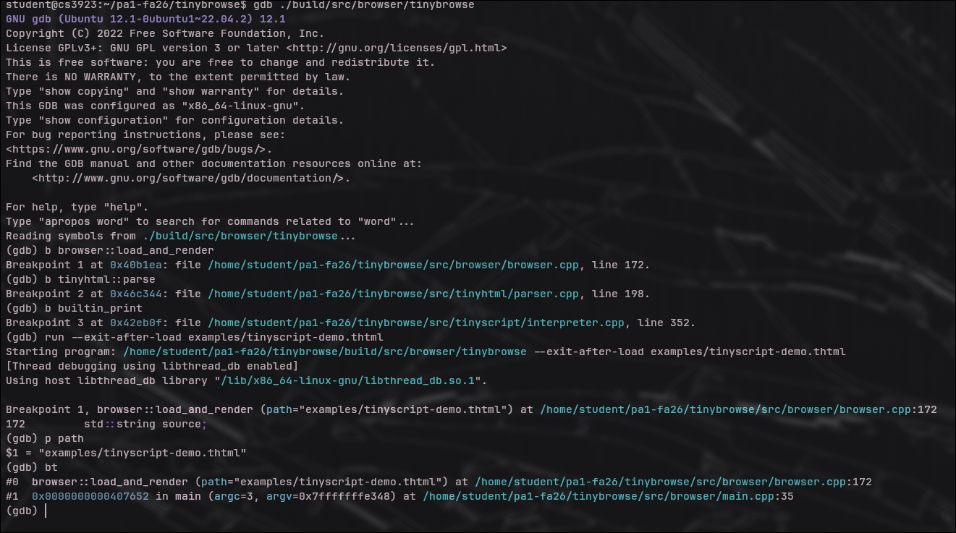
2.2
number of frames at the tinyhtml::parse breakpoint:
[4]
does each frame's module (directory under src/) match what you expected from the load pipeline?
[Yes. The stack follows the expected pipeline: main starts the program, browser::load_and_render loads the requested file, browser::render_document_source processes the loaded document source, and tinyhtml::parse parses that source into the document structure.]

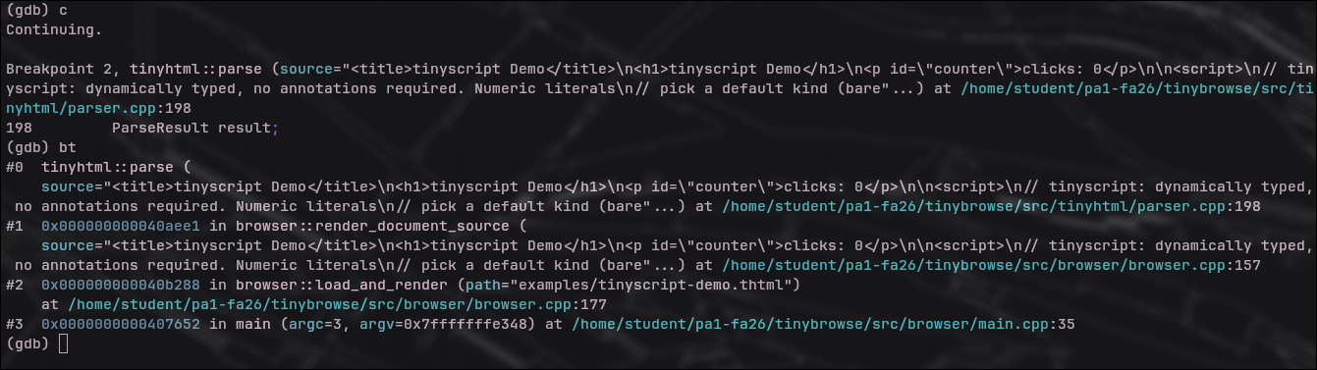
Ls

2.3
memory region containing args[0] (heap or stack): [ heap]
memory region containing state (heap or stack): [stack]
why does it make sense that they live in different places: [args is a std::vector, so its elements are stored in dynamically allocated memory on the heap. state is part of the current function call's local execution context, so its storage is associated with the stack. This separation makes sense because vector element storage can outgrow a single stack frame, while local execution state is tied to the lifetime of the current function call.]

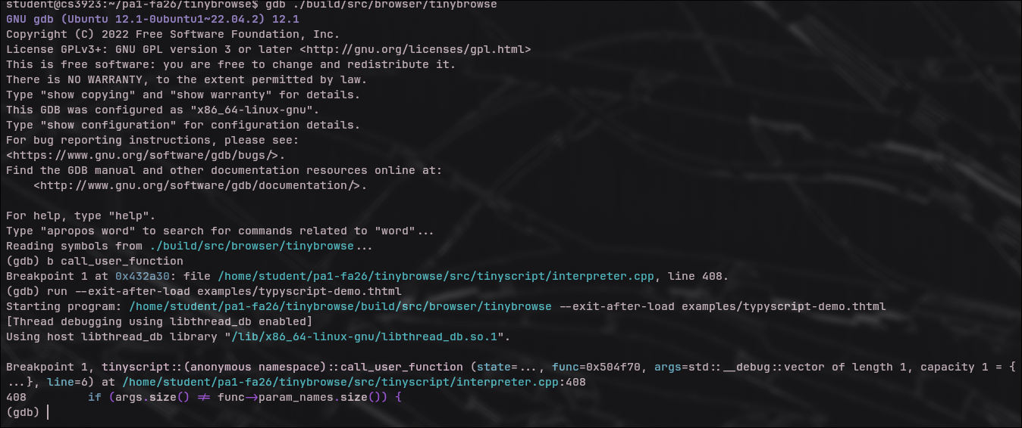

--- Part 3: Using strace ---

3.1
roughly how many syscalls for hello.thtml, unfiltered: [About 77 total. ]

how many are tinybrowse's own work (as opposed to OS/process setup): [ Only about 8–10 were directly related to tinybrowse's work: opening astracnd reading hello.thtml, closing the file, and writing the rendered output. The large majority, roughly 65–70 syscalls, were process/runtime setup such as loading shared libraries, mmap/mprotect calls, heap initialization, and other OS startup work.]

3.2
number of write() calls for tinyscript-demo.thtml: [7]
file descriptor(s) targeted: [1 and 2]
roles of fd 1 and fd 2: [fd 1 is standard output (stdout), used for the rendered page output. fd 2 is standard error (stderr), used here by tinyscript print/debug-style output such as 5, 3, 20, and "updated the counter".]
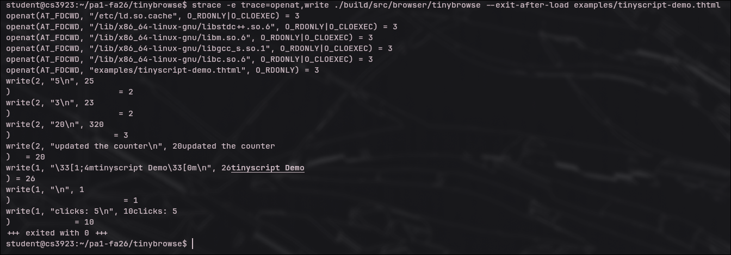
3.3 -- threat modeling
example attacker-supplied path: [../../../../etc/passwd]
what vulnerability it could lead to: [A path traversal / arbitrary local file read vulnerability. If attacker-controlled href data reached read_file(), the attacker could use ../ sequences to escape the intended directory and read sensitive files such as /etc/passwd.]
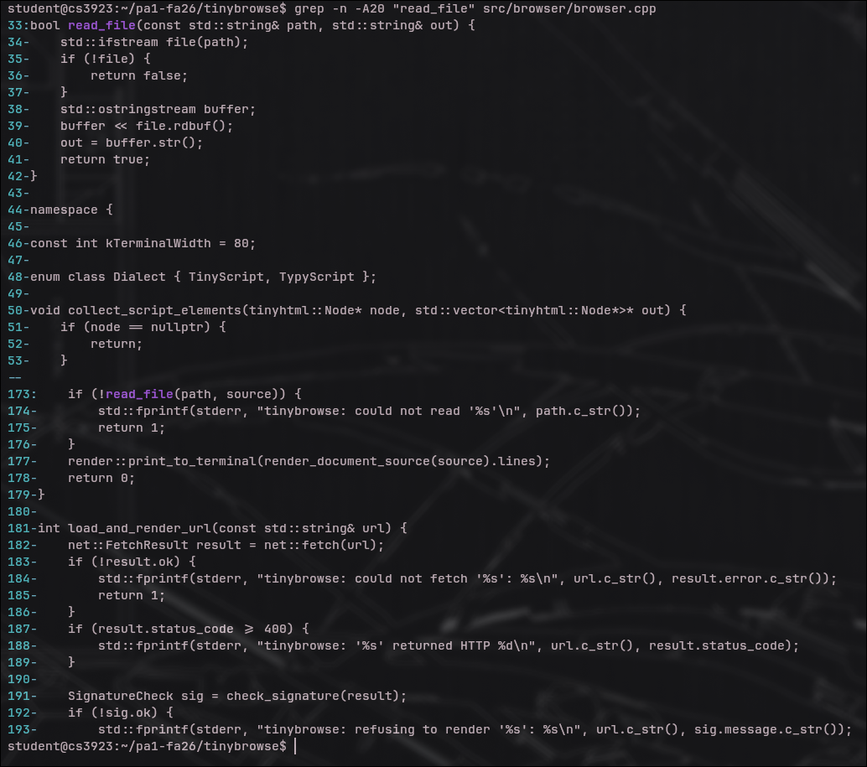
(END)

